39.4: a) 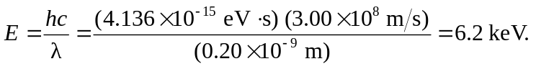
b) 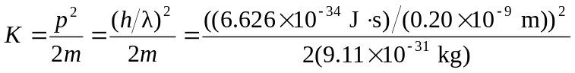
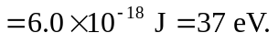
Note that the kinetic energy found this way is much smaller than the rest energy, so the nonrelativistic approximation is appropriate.
c)
5.2 meV. Again, the nonrelativistic approximation is appropriate.

